***Analyzing the Relationship Between Walmart Stock Performance and S&P 500 Index Movements:***

***A Financial Market Analysis***

**Introduction**

In this project, we aim to explore the relationship between Walmart's stock prices and the broader market trends indicated by the S&P 500 index. The goal is to understand how market movements influence Walmart's stock performance, potentially providing insights into investment strategies and financial planning.

**Analysis Approach and Methodologies**

**Correlation Analysis**  
Initially, a correlation analysis will be performed to measure the extent to which changes in Walmart's stock price are linked to variations in the S&P 500 index. This will give an idea of how closely the performance of Walmart's stock is related to the general movements in the market.  
  
**Regular Least Squares (OLS) Analysis**To learn more about the nature of the link between the two variables, we will perform an Ordinary Least Squares (OLS) regression after the correlation analysis. With the use of this regression model, we can determine how much changes in the S&P 500 will affect the price of Walmart's shares. This predictive model may be used as a tool for financial analysis and decision-making.

**Classification Analysis**

To further our analysis, we will employ classification techniques to categorize the daily changes in Walmart's stock prices into three distinct categories: 'Increase', 'Decrease', and 'Stable'. This part of the analysis will help us understand the distribution of these performance categories within the dataset, revealing how often significant price changes occur, and under what market conditions.

**Enhancement of the Project**

In-Depth Company Analysis of Walmart

To enhance the project, we will delve into an in-depth company analysis of Walmart. This will involve examining Walmart’s financial reports, market position, growth strategies, and any external factors affecting its stock performance. Such a comprehensive analysis will provide context to the numerical data and help explain some of the trends and patterns observed in the regression and classification models.By combining quantitative analysis with qualitative insights, this project aims to provide a holistic view of Walmart's stock performance in relation to market indices, particularly the S&P 500. This approach not only aids in better understanding past patterns but also enhances the predictive power of the financial models used, potentially leading to more informed investment decisions.

**Data Retrieval**

For this project, the dataset encompassing the daily price movements of the S&P 500 index and Walmart's US stock prices was meticulously retrieved using the Bloomberg Excel plug-in. This powerful tool is integral for accessing real-time financial market data, analytics, and historical information directly within Excel, which is essential for conducting comprehensive financial analysis.

**Utilizing Bloomberg Excel Plug-In:**

Access and Integration: The Bloomberg Excel plug-in allows seamless integration into Excel, providing the capability to pull live financial data, historical pricing, and market analytics directly into spreadsheets. This integration is vital for financial analysts and researchers who require up-to-date and historical data for analysis.

Data Extraction: For our project, specific formulas provided by the Bloomberg plug-in were used to extract daily closing prices for both the S&P 500 index and Walmart's stock. The commands within the plug-in facilitated the retrieval of accurate and timely data, ensuring that our analysis is based on reliable and relevant market information.

Automation and Efficiency: The plug-in's functionality includes the ability to automate data retrieval processes, significantly reducing manual data entry and the associated risks of errors. This efficiency is crucial in handling large datasets, allowing analysts to focus more on analysis rather than data collection.

Importance of Reliable Data Sources:

Using the Bloomberg Excel plug-in not only enhances the reliability of the data but also enriches the analysis with comprehensive market insights that are critical for understanding stock performance in relation to market trends. The ability to access Bloomberg’s vast database offers an invaluable resource for conducting detailed financial analysis and modeling.

This method of data retrieval underpins the project’s analytical framework, providing a robust foundation for the correlation analysis, OLS regression, and classification methods used to examine the impact of market fluctuations on Walmart’s stock performance.

**Formula used**

For SPX Index:

=BDH("SPX Index", "PX_LAST", "start_date", "end_date", "calculationType=return")

For WMT US Equity:

=BDH("WMT US Equity", "PX_LAST", "start_date", "end_date", "calculationType=return")

**Exploratory Data Analysis**

1. **Trend Analysis**

This analysis will show how Walmart's stock prices and the S&P 500 index values have moved over time, providing insights into their growth trends or any potential declines.

The graph shows Walmart's stock price and the S&P 500 on different scales, making Walmart's stock appear relatively flat, whereas the S&P 500 exhibits more pronounced fluctuations. Walmart's stock price remains relatively stable and flat throughout the observed period. The minimal change in Walmart's stock might suggest steady performance without significant growth or decline, or it could be due to the scale overshadowing more subtle variations in the stock price. The S&P 500 index shows a general upward trend with noticeable fluctuations. There are periods of sharp rises followed by declines, indicating typical market cycles of growth and correction. The overall trajectory is upward, reflecting growth in the market or recovery from previous downturns over the decade.

**2.Volatility Analysis**

The provided graph displays the daily percentage changes (volatility) for Walmart's stock and the S&P 500 index from 2014 to 2024.

Both Walmart and the S&P 500 show fluctuations in daily percentage changes, but the S&P 500 exhibits larger spikes, indicating higher volatility compared to Walmart. Walmart's stock shows fewer extreme values in daily changes, suggesting it is less volatile and possibly more stable than the broader market represented by the S&P 500. Periods of significant market volatility (large spikes in the S&P 500) occasionally correspond to noticeable changes in Walmart's stock, but Walmart generally maintains smaller fluctuations, indicating it may not be as reactive to market conditions as other stocks or the index itself. Walmart’s relative stability might be due to its large market capitalization and its business model, which is less susceptible to market shocks compared to other sectors. The S&P 500's higher volatility reflects its sensitivity to broader economic changes and market sentiment, impacting a wider range of sectors.

**2.Distribution and Correlation of the returns (daily percentage changes) of Walmart's stock compared to the S&P 500**

The results from the two graphs provide insights into the daily returns and their correlation for Walmart and the S&P 500 over a given period. The scatter plot shows a moderate correlation coefficient of 0.44, indicating a positive but not strong relationship between the daily returns of Walmart stock and the S&P 500 index. This suggests that while Walmart’s stock movements are somewhat influenced by the overall market, there are other factors at play specific to Walmart that affect its stock performance. The histogram further illustrates this point, showing the distribution of daily returns for both Walmart and the S&P 500. Both distributions are roughly bell-shaped, suggesting normality, but the Walmart returns are slightly narrower, indicating less volatility compared to the broader market. This aligns with Walmart’s reputation as a stable stock with fewer extreme fluctuations than the market average.

**Company Overview Analysis**

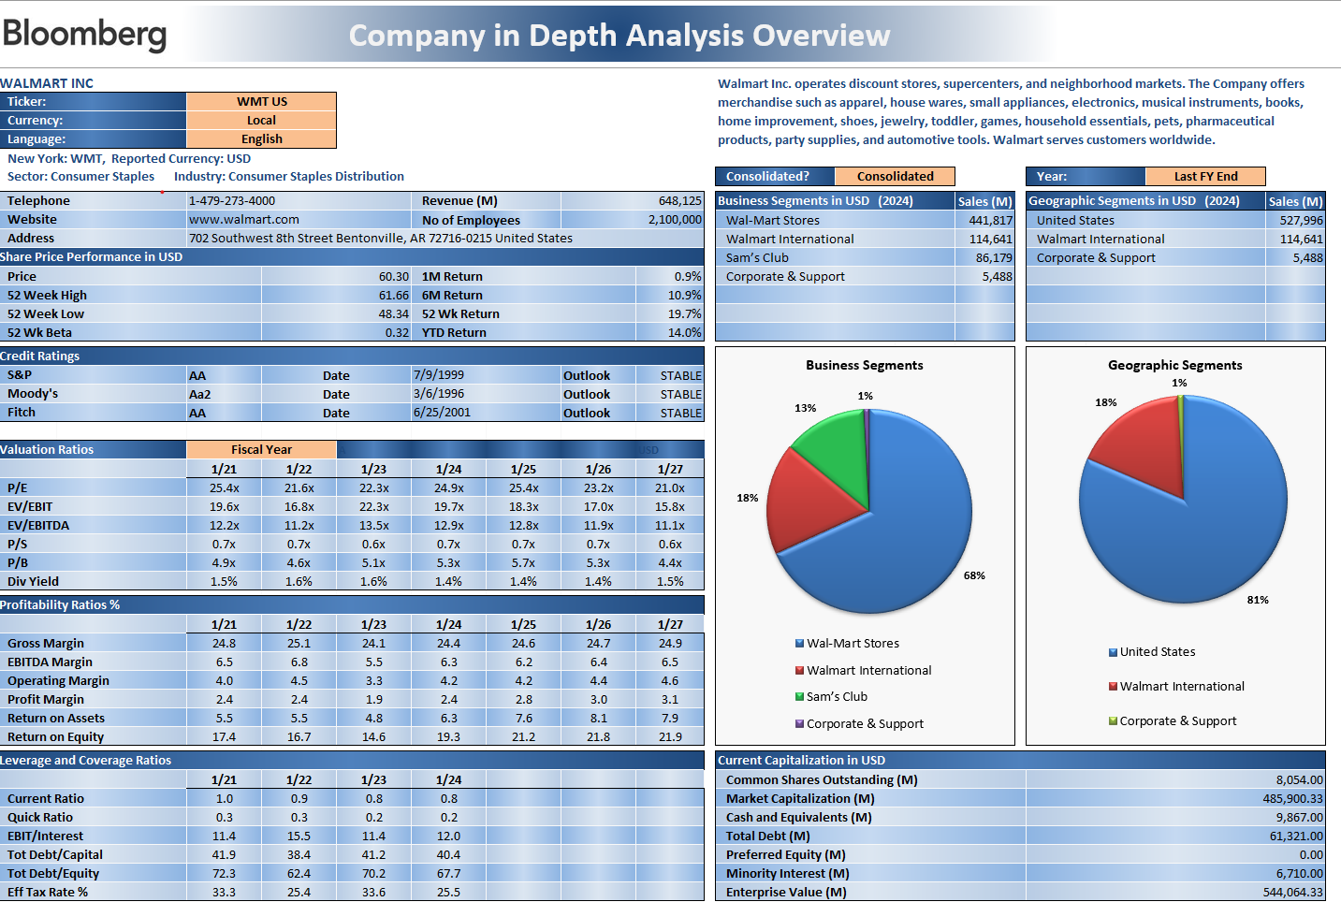

**Company Overview**

Walmart Inc. is a major player in the consumer staples distribution sector. It operates a network of discount stores, supercenters, and neighborhood markets globally. The company's product portfolio includes apparel, small appliances, electronics, musical instruments, books, home improvement items, shoes, jewelry, toddler items, games, household essentials, pet products, party supplies, and automotive tools. Walmart is renowned for serving diverse customer needs worldwide.

**Financial Performance**

As of the latest reporting, Walmart shows a robust revenue of $648,125 million with a substantial workforce of 2,100,000 employees. The share price as reported is $60.30 with a 52-week high of $61.66 and a low of $48.34, indicating a relatively stable stock performance over the past year with a total year-to-date return of 19.7%.

**Business and Geographic Segments**

Walmart operates through various business segments, with the major contributions coming from:

Wal-Mart Stores: $441,817 million

Walmart International: $114,641 million

Sam’s Club: $86,179 million

Corporate & Support: $5,488 million

In terms of geographic distribution, the United States is the primary market, accounting for $527,996 million of the sales, which is about 81% of total revenue, with international markets contributing the remainder.

**Financial Ratios and Market Capitalization**

The company maintains strong valuation ratios with a Price to Earnings (P/E) ratio improving slightly from 25.4x in FY 2021 to 21.0x in FY 2027. Other ratios such as EV/EBITDA and P/B indicate a healthy financial structure and asset valuation. Profitability metrics such as gross margin and EBITDA margin are consistent, showing careful cost management and operational efficiency.

**Credit Ratings and Outlook**

Walmart holds a stable credit outlook with ratings of AA (S&P), Aa2 (Moody’s), and AA (Fitch). This suggests a strong creditworthiness and low default risk, reflecting its solid market position and financial stability.

**Capital Structure**

The total market capitalization stands at approximately $485,900.33 million with an enterprise value of $544,066.33 million. The current capital structure includes $9,867 million in cash and equivalents and a significant debt load of $61,321 million, which the company efficiently manages with a total debt to equity ratio of 70.2%.

**Conclusion**

Walmart Inc. exhibits a robust market presence and stable financial health across multiple business divisions. The company's broad global operations and strategic management enable it to retain a steady financial outlook despite several problems, including a significant debt burden. Its competitive edge in the changing retail landscape is probably going to be sustained by maintaining a focus on market expansion and operational efficiency.

**Applying Machine Learning Algorithm**

**1.OLS Regression Analysis**

Use OLS regression to model Walmart's stock price as a function of the S&P 500 index. This approach will give us detailed insights, including coefficients, p-values, confidence intervals, and diagnostic metrics.

**Model Summary:**

R-squared (0.905): This value indicates that approximately 90.5% of the variability in Walmart's stock price is explained by the S&P 500 index. This suggests a strong linear relationship between the S&P 500 and Walmart's stock prices.

Adj. R-squared (0.905): Adjusted R-squared confirms that the fit is robust and not overly influenced by any one feature given it's nearly the same as the unadjusted R².

Coefficients:

Intercept (1.7503): When the S&P 500 index is zero, the predicted value of Walmart's stock price is approximately 1.7503. This theoretical intercept might not have practical significance due to the nature of the data.

S&P 500 (0.0112): For every one-point increase in the S&P 500 index, Walmart's stock price is expected to increase by 0.0112 units, with a p-value of 0.000 indicating high statistical significance of this predictor.

**Statistics:**

* F-statistic (2.398e+04): This is highly significant (p < 0.000), confirming that the overall model is statistically significant.
* Durbin-Watson (0.020): This statistic indicates positive autocorrelation, which is common in time series data.
* Jarque-Bera (74.606): The test is significant (p = 6.30e-17), suggesting that the residuals are not normally distributed, possibly due to skewness or outliers in the data.
* Condition Number (1.12e+04): Indicates potential multicollinearity or other numerical issues, which might affect the stability or interpretation of the regression coefficients.

**2.Classfication Model**

The data is pre-processed to create a target variable that categorizes the daily price changes. We'll use a simple threshold to define 'stable' and label the data accordingly. I'll proceed with these steps now. The stock performance categories have been defined as follows based on the daily percentage change, using a threshold of 1% to determine 'stability':

Increase: If the percentage change is greater than 1%.

Decrease: If the percentage change is less than -1%.

Stable: If the change is between -1% and 1%.

Now we can analyze the distribution of the 'Performance' categories (Increase, Decrease, Stable) within the dataset to understand how often each outcome occurs. This will give us insight into the balance of the classes and the frequency of stock price increases or decreases. Understanding the distribution is crucial for selecting and evaluating the model since imbalanced classes can bias the model's performance.

We will then compute the frequency of each category in the dataset and visualize it to provide a clarity on how often stock prices have increased, decreased, or remained stable.

The majority of the data falls into the 'Stable' category, while 'Increase' and 'Decrease' categories are significantly less frequent. This imbalance can affect the training of classification models, as they might become biased towards predicting the most common class ('Stable'). There are significantly fewer days with notable increases or decreases in stock price compared to days where the price remained relatively stable. This could reflect a generally stable stock with occasional volatility.

**3.Correlation between Walmart Stock prices and S&P 500 Index**

To assess the correlation between Walmart stock prices and the S&P 500 index values, the Pearson correlation coefficient is calculated using Python. This coefficient measures the linear relationship between two variables, with values ranging from -1 to 1. A value closer to 1 indicates a strong positive correlation, where the values of both variables tend to increase together. A value closer to -1 indicates a strong negative correlation, where one variable increases as the other decreases. A value around 0 suggests no linear correlation.

The Pearson correlation coefficient between Walmart stock prices and the S&P 500 index values is approximately **0.951**, which is quite high.

A correlation of 0.951 suggests a strong positive relationship between Walmart stock prices and the S&P 500 index. This elucidates that as the S&P 500 index tends to increase, Walmart's stock price generally increases as well, and vice versa. This correlation might reflect that Walmart's stock performance is heavily influenced by the overall market trends, which is common for large-cap stocks that have a significant weight in the index.

**Conclusion**

The relationship between Walmart's stock performance and the larger market trends as shown by the S&P 500 index was examined in this financial analysis project. We obtained daily stock prices for Walmart and the S&P 500 by using the Bloomberg Excel plug-in, guaranteeing a strong dataset for in-depth examination. We compared the daily fluctuations and long-term movements of both indices to perform trend and volatility assessments using exploratory data analysis (EDA). A scatter plot of daily returns used for the correlation research revealed a moderately positive correlation, indicating that while Walmart's stock does respond to general market movements, it also has distinct company-specific elements influencing its stock behavior.

Distribution study of daily returns provided further information, indicating Walmart's lower volatility relative to the market, which may make it a safer investment for people who are risk adverse. While the modest correlation indicates some degree of synchronization with the S&P 500, Walmart's stock is particularly stable, indicating that it is resilient to market volatility. By adding more in-depth economic events and predictive modeling to predict Walmart's stock movements based on expected market developments, future research could build on these findings. For investors and financial planners concentrating on the relationship between big corporate equities and market dynamics, this foundational analysis is a useful tool.